At the very entry of our School yard, just in front of the main entrance, is located a big ugly utility building. It is a metal construction used as storage and for many years we have been struggling to make it look better.
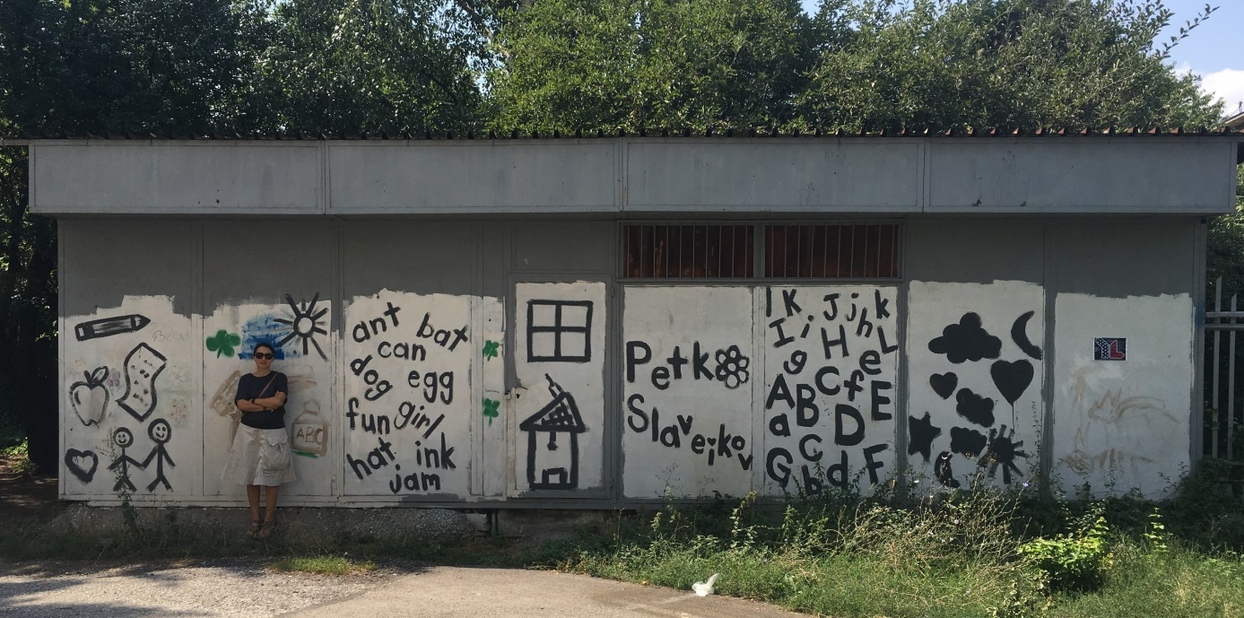
The utility building as it looked before
This year a group of parents initiated a total makeover of this building. In the last years in Bulgaria an artist named Nasimo – graffiti writer, became very popular with his big size graffiti art on public buildings and places. We invited him to develop a project for our utility building and he agreed.
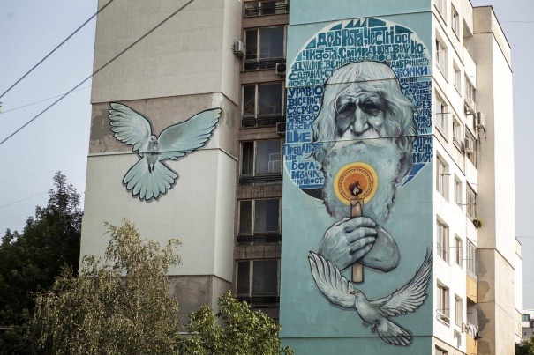
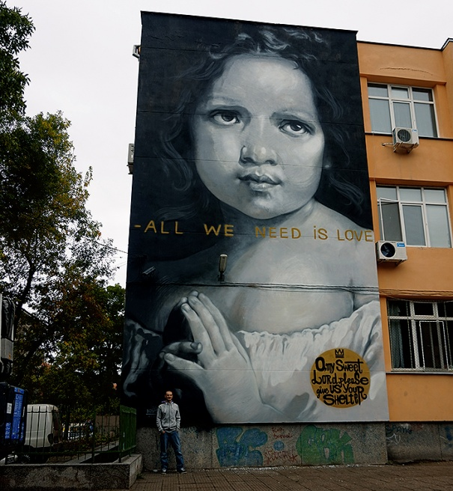

Nasimo’s art

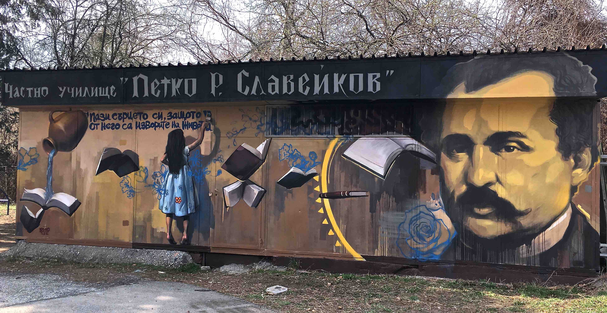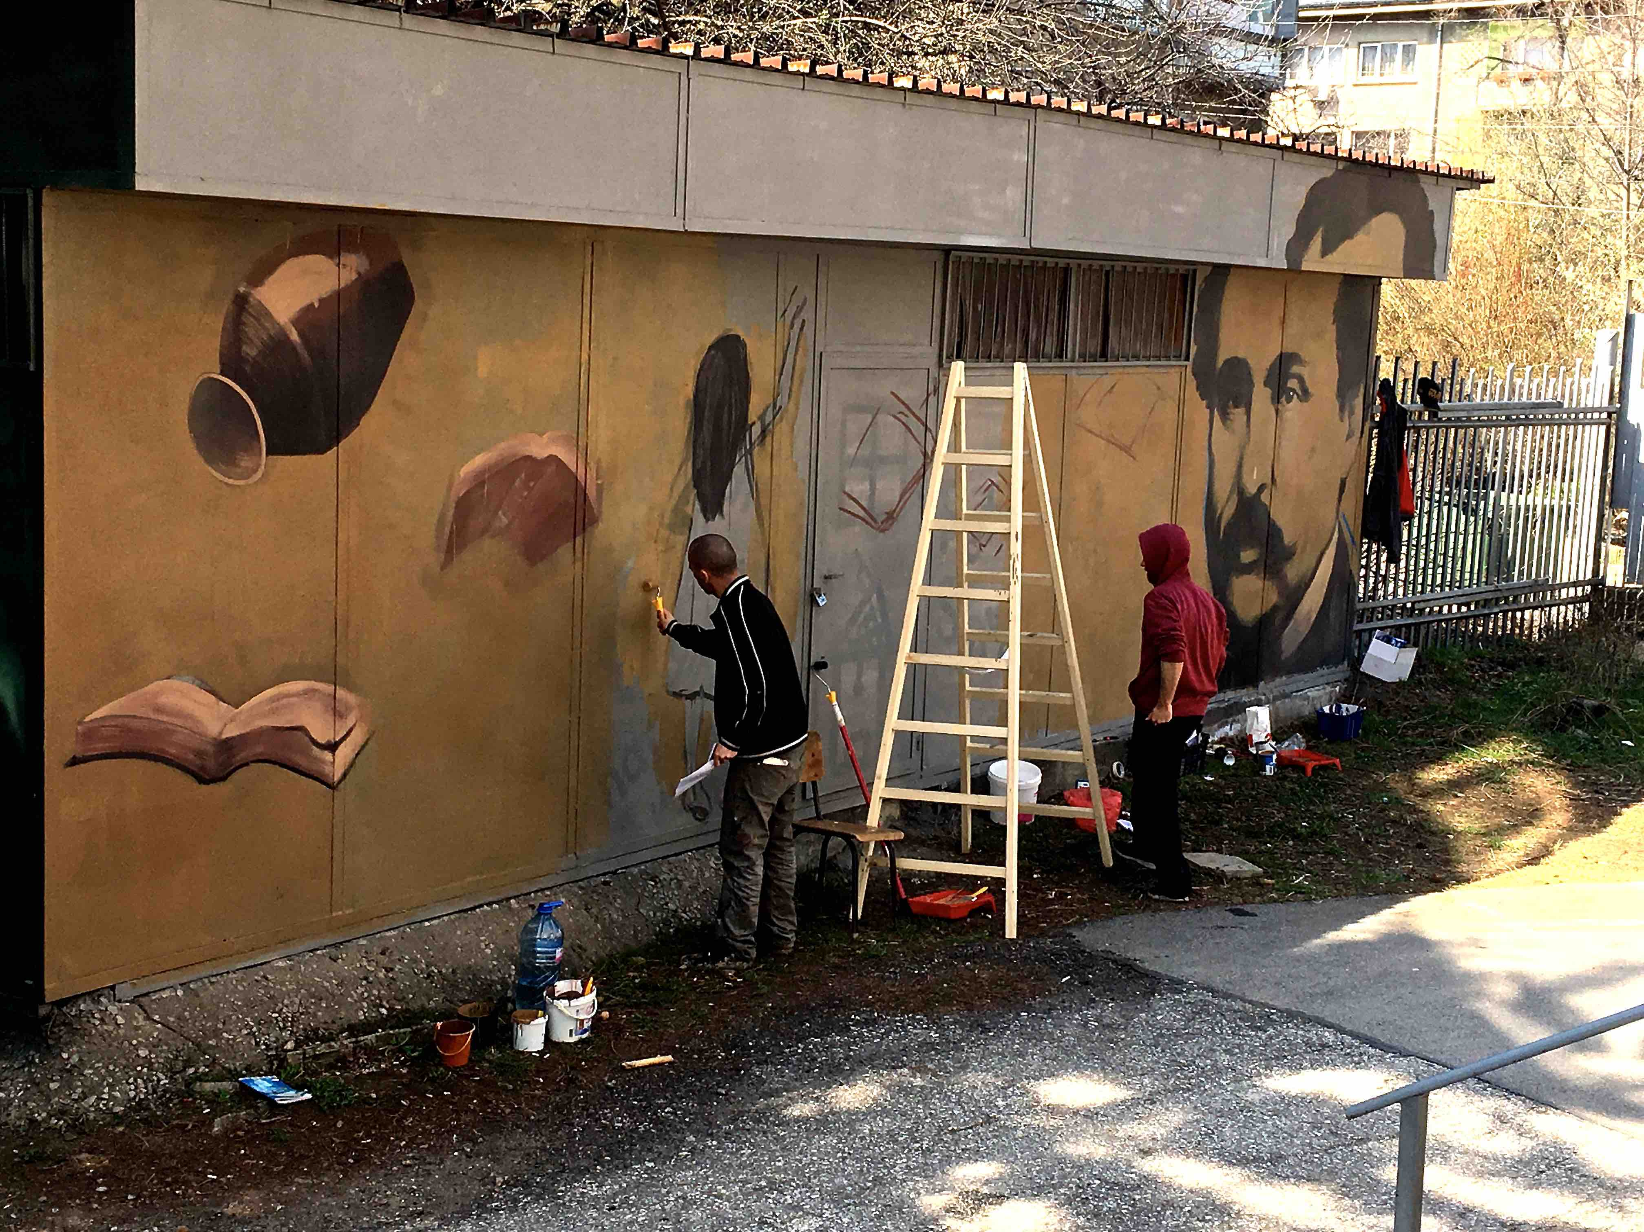
Final result
Work in progress
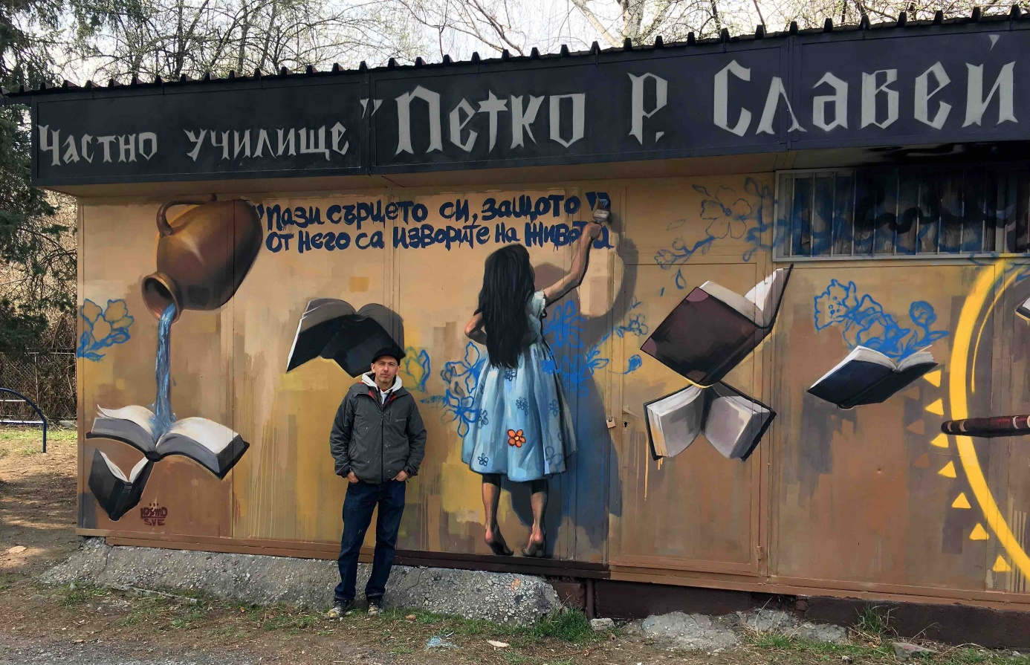
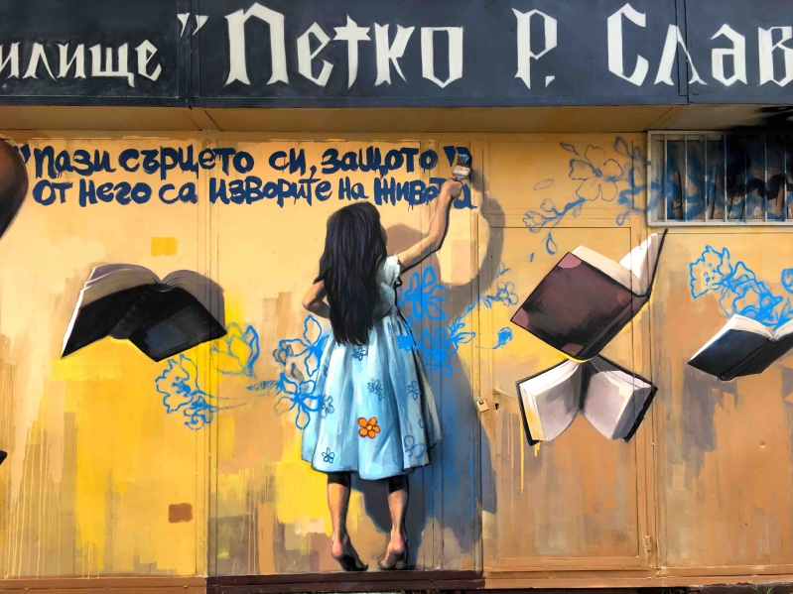
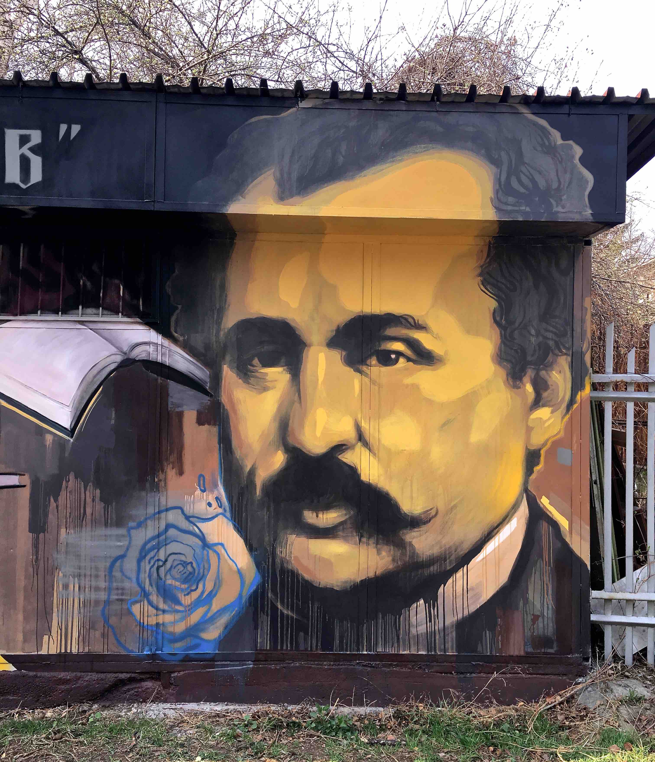
Nasimo in front of his creation
The girl is writing: “Guard your heart; for everything you do flows from it!”
On the right is the portrait of Petko R. Slaveikov, after whom our school was named
This renovation helped us not only to create a more аesthetic and welcoming environment for our kids but also to popularize our school, as all Nasimo’s projects are posted online and his works are followed by many people.
The whole project cost was 750 euro.

