“ We know that you are a letter of Christ drawn up by our ministry, written not in ink but by the Spirit of the living God, not on the stone tablets but on the tablets of human hearts.”

2 Corinthians 3:3

A letter of Christ…

Each letter has a sender, recipient and content. We are not here by chance - we were born not of blood, nor of the fleshly will, nor of the will of the man but of God (John 1: 12-13). We are Christ's letter and ambassadors of Christ. The sender of this letter is God. Addressees are people around us. Our words, our deeds, the testimony of life are Christ's message to those among whom we live. How do others read us? Is the message understandable???
News from the south of India (Tamilnadu)…

On 10 April 2018, a wave of protest swept through Chennai - Dalit Christians openly protested against discrimination, humiliation and rejection experienced in Christian churches. If you come from the lowest caste - despite the biblical teaching - no one in the church will give you a hand to welcome you, nor will sit next to you in fear of defiling. Not to mention priesthood - 13 years of theological studies is not enough, because as Dalit you can clean the toilets, sweep the streets, work as a scavenger but not as a teacher of the Word of God...
I have heard of cases of great commotion and split in the church because of the fact that the family of the deceased Dalit wanted to bury the corpse of a relative in the cemetery and not beyond its borders. "Loving" brothers and sisters in Christ rebelled and did not allow such an innovative act to take place because it would kill the heart of their Indian culture.
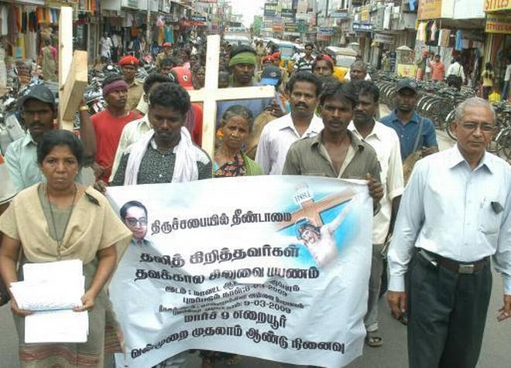

Interesting…

On the poster of protesting Christians, next to the image of Christ, there is a photo of Dr. B. R. Ambedkar (1891-1956) first educated Dalit, also known as the Father of the Indian Constitution. He was a lawyer, an outstanding social reformer and politician who had completed his education in the United States (Columbia University in New York) and England (London School of Economics). Throughout his life, he fought for the rights of Dalits and other disadvantaged social classes. Ambedkar was appointed the first minister of Indian law in the government of Jawaharlal Nehru. He was posthumously awarded the Bharat Ratna, the highest civil honor of India in 1990.
Throughout his childhood Ambedkar struggled with discrimination, humiliation and rejection. Originating from the Hindu caste "Mahar", he was seen as "untouchable" by the upper caste. Although he attended school, Ambedkar and other untouchable children were segregated and given little attention or help by teachers. They were not allowed to sit inside the class. When they needed to drink water, someone from a higher caste had to pour that water from a height as they were not allowed to touch either the water or the vessel that contained it. This task was usually performed for the young Ambedkar by the school peon, and if the peon was not available then he had to go without water; he described the situation later in his writings as "No peon, No Water". He was required to sit on a gunny sack which he had to take home with him.

Prayer requests…
- For improving the situation of Dalits, who make up over 20% of the Tamilnadu population;
- For the Church in India - to truthfully represent the name of Christ - to be the salt of the earth and the light in darkness;
- For the recruitment of students to the EBI (Emmanuel Bible Institute) - in the light of recent events, my desire and prayer is that the Dalits may also study at our institute.
- Also the truth is - the harvest is plentiful but workers very few… – so we call to the Lord of harvest to send us students and call the workers to harvest. Please pray with us

