Parakletos News Letter
November 2022

Parakletos Ministry
We exist to facilitate the church to be a safe, honest, and intimate place to meet, know, and grow in Christ and His Body.
Parakletos creates a safe place through means of individual and marital counseling, teaching, and mentoring.
parakletos@volny.cz

Dear Friends,

What a strange year we have been through. Another strange year. Once we have got out of covid crisis, there is Ukrainian crisis and energy crisis. But surprissingly there have been, in our experience, greater oportunities for ministry than ever.
We are just at the end of two month’s series of seminars and conferences. Virtually every weekend we traveled usually for three days and we presented lectures and seminars. Especially during this post-covid time people are recovering and come back to their lives as they knew them before. We encounter a lot of disorientation but also a new desire to recollect and look under the surface of everyday lives. In a way, people are more open after the crisis. Surprisingly, unlike six months ago, now the conferences and seminars are crouded. People want to deal with issues in their post-covid lives.
Last two months we travelled over weekends and during the weeek we had personal mentoring meetings, counseling, discipleship Bible study groups and always worked on materials for the next conference. We feel tired but also fulfilled realizing how privileged we are to be able to serve God at this challenging times.

“Naděje” Evangelistic Seminar
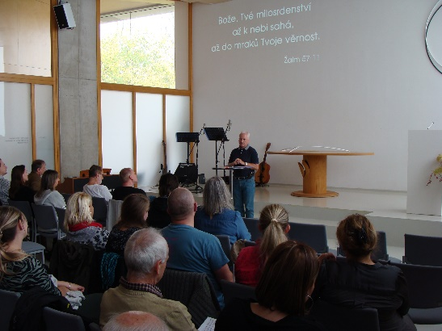
One of those seminars that we did was for a Christian Social Care organization called “Naděje”, “Hope”. That non-for-profit was established right after collapse of communism and has grown to 800 employees. Many of those are not believers so they offer every year a conference which is focused on an issue of concern with underlying Gospel theme. We had privilege to speak there this year. In an atheistic culture it is challenging to recognize how to speak about Jesus and not to go too far because not everyone is ready. Sometimes we wait until the last minute to know what kind of raport was built and based on that how much we can say.
Both days people responded very positively and we spoke quite deeply about realities of our lives. So we had courage to be very open about our personal source of hope and strength. Everyone seemed to take it well. We just desire that God will continue to work in those people’s hearts. Even in that short time which we had, many of those participants became dear to us.

Family Conference
In the last eighteen years we have been working with a group which has been organizing a conference for families. This year it was the twenteeth conference. We spoke at five of those conferences and were invited also this year. We developed a very special relationship with founders of that ministry so that we not only collaborate with them but we have also been personally encouraging and supporting them in all their needs.

Church Retreat
One church asked us to speak at their retreat. There has been painful conflict in that fellowship with a resulting division. Many painful things happened. We based our discussion in the book of Nehemiah and spoke about emotional proper response, about repentance and new beginning. God was amazingly at work. One evening after our lecture people, touched by the Holy Spirit, in their prayers spontaneously confessed their sins. One of the most amazing things we have ever seen. God was obviously present. We keep in touch with that church in kind of consulting role.

New Book
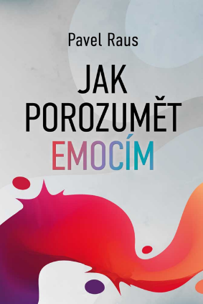
Finally Pavel’s new book is being published. Pavel worked on it for several years and honestly unless he became sick with covid in June, he would have not been able to finish the book.
The theme is „emotions“. The title in Czech is „How To Understand Emotions“. The topic of emotions kept coming up at the seminars and personal conversations as a significant challenge for those we have been working with. It had been precious to be in discussion with so many different individuals and couples, and to see their responses, identify their needs, and test ideas about how to respond in God glorifying ways to those needs.
Just for you to understand, the Czech Republic is a small country and book market is small. If someone sells 10,000 copies, it is considered a bestseller. To sell 1,500 for publishers breaks even. Financially, from the previous book which sold reasonably well, Pavel got in royalties about $ 1,000. It is a ministry. And quite effective ministry because all the time people tell us that the previous book changed their views and helped their marriages. In fact, with each book we pray not only for sales but that God would use it to convert 100 new Christians and save 50 marriages.

Thank You
Lately we realized that we have not done much for all of you who have been faithfully supporting us in years. We were so focused on serving people here that we did not give it sufficient attention. It is not that we would not value contribution of each of you. In fact, you are deeply in our hearts. Without you we could have not done for marriages, pastors, churches, and for the Gospel in our country what we did.
T h a n k y o u!
You are in our prayers regularly!

Have a nice Thanksgiving and Advent!

Pavel and Julka Raus

For financial support from the US you can send tax deductible contributions to Bridge to Life Ministries, 17194 Van Wagoner Rd, Spring Lake, MI 49456. Make the check out to Bridge to Life and designate the gift for CCMCR or Parakletos.
Or send check to LeadingEdge, PO Box 27, Strasburg, OH 44680 for Parakletos. Online giving at: https://www.leadedge.org/parakletos.

From the UK: CAF Bank, Acc Name: Central Eurasian Partners, Sort code: 40-52-40, AccNo: 00016282, designate to Parakletos.

From the CZ: ČSOB Bank, AccNo: 186 694 169 / 0300

