**Parakletos News Letter**

**March 2025**

**Parakletos Ministry**

We exist to facilitate the church to be a safe, honest, and intimate place to meet, know, and grow in Christ and His Body.

Parakletos creates a safe place through means of individual and marital counseling, teaching, and mentoring.

parakletos@volny.cz

Dear Friends,

In the midst of rapidly changing world it is so good to remind ourselves that God is the One who never changes. And he is still our security and salvation even if many other things no longer are. Today’s world, however, still is a place where God works, even more powerfully than ever before. We wish to share with you how he has been working in our lives and lives of those around us.

We had very busy beginning of this year. In fact we had a seminar or lecture every weekend until mid March with exception of two weekends. And on top of that also some lectures during the week. It was demanding physically and mentally but also very encouraging. So much good is going on in our country and so many people do great things for the Lord.

Most rewarding of all for us though is individual work with Christian leaders. We travel either to Prague or to another city Pardubice and we have the whole day of meetings at McDonalds. Some people also travel to our town to meet with us. And sometimes we use ZOOM. Pavel meets with men and Julka meets with women. We are amazed how significant that time is for young men and women. We think that in our culture such support and focused attention given to them has never been part of people’s experience. Neither at home nor at church. Because we lacked exactly the same in the past, we understant what thay miss.

Sometimes we work on a specific need, personal or ministry, but many times we have no agenda. Almost always there is though a significant deeper discussion about issues which concern them. Often with tears and new revelations and clarified action steps. Honestly, often we are so tired at the end of such a day. But also fulfilled and privileged that we can be part of the way God works in lives of those dear people.

However, we also have to admitt that often we encounter really serious and difficult struggles. Today many people are deeply hurt and Christian leaders are no exception. We dive with them into pain, confusion, insecurity, and frustration. The more encouraging then it becomes to see how they grow and mature even through a lot of pain.

Summit 2025

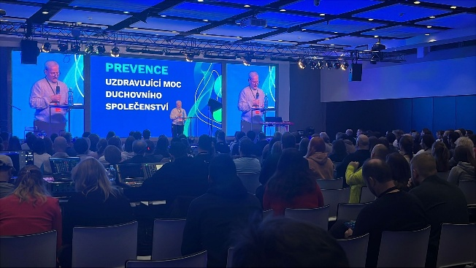 Five denominational youth leaders started to talk together about issues they deal with in their churches. They identified an overwhelming problems in mental health area. The decline of mental health is so serious and wide spread that they felt that they need to do something about it. As result they organized a conference intended for youth leaders to equip them.

The conference took place at the end of January. They hoped to have at least 200 participants but in the end 700 people signed in. It was a clear sign of the extent of the problem.

We had there two plenary talks and four seminars and we also were available for individual counseling. And we met informally many people. We focused on Gen Z which we have been attempting to figure out intentionally for the last several years. Even though we are outsiders, surprissingly, the feedback of several Gen Z was that it was exactly what they experienced. That was a kind of homage for us.

We were somewhat sceptical about the potencial of such a conference, how much training can be accomplished. But the main benefit really was that realities in today’s young people’s lives have been brought up to an attention. Hopefully, it will bring about a change of thinking and more resources for churches.

For us it was interesting also because exactly those same needs we observed already in 1980’s and later we developed our ministry to prepare the church for, as we called it, „the needs of the Third Millenium“. Now it has become obvious all through the country.

National Week for Marriage

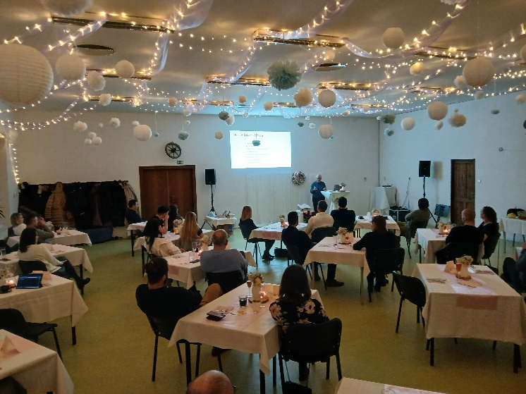 Many churches use time around Valentine’s Day to organize seminars and lectures to strengthen marriages and families. Many of those are used as reach out to non-believers, neighbours and friends. Some are arranged in a very romantic settings. We had opportunity to be at several of those. It is always a great opportunity to share Christ in a very practical way in the area of relationships, which is very important to everyone.

In one of those we spoke about „What Makes A Happy Marriage“ and another was about „Mood of Home“. We also spoke about the need and necessity of change in an intimate relationship. That was more a one day seminar. After the seminar one man approached us with a comment, saying that „I never realized that you can even talk about these things on such a profound level“. He obviously gained new understanding and broadened his perspective to his marriage.

Family

Our granddaughter Elisa will have her dedication in church in Denmark later this month so we will travel to be with her. Jana, the younger daughter, finished her time in the UK and moved now to Portugal to think about what does God have for her next.

Thank you for your prayers and support!

Pavel and Julka Raus

For financial support from the US you can send tax deductible contributions to Bridge to Life Ministries, 17194 Van Wagoner Rd, Spring Lake, MI 49456. Make the check out to Bridge to Life and designate the gift for CCMCR or Parakletos.

Or send check to LeadingEdge, PO Box 27, Strasburg, OH 44680 for Parakletos. Online giving at: https://www.leadedge.org/parakletos.

From the UK: HSBC Bank (Business account), A/c name: Central Eurasian Partners, Sort code : 40-36-15, A/c no. : 43825051, designate to Parakletos.

From the CZ: ČSOB Bank, AccNo: 186 694 169 / 0300